1.1 Install Source Code via SAPlink

The ABAP Report Wizard was developed on NetWeaver 7.0. It leverages the ALV Object Model which was introduced in NetWeaver 2004, so it should work on that release as well. Unfortunately, this solution will not work on releases prior to NetWeaver 2004.

The first step is to import the SAPlink nugget file into your system. If you do not have SAPlink installed on your system, you can download it from http://code.google.com/p/saplink/. You will also need the following plug-ins which can be downloaded from http://code.google.com/p/saplink-plugins/.

Required Plug-ins

- Function Groups
- Message Classes
- Dictionary Objects
- Documentation

Once you have SAPlink and the required plug-ins installed, you can run the executable program, ZSAPLINK. Select the radiobutton for “Import Nugget”, and select the nugget file from the file location. Lastly, click the “Execute” button, or hit F8.

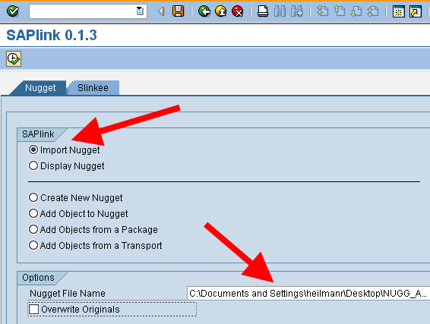

Hopefully, the following screen will yield all success messages, signified by the green lights.
Notice that most of the imported objects follow a similar naming convention, and hopefully these objects do not conflict with existing objects in your system.

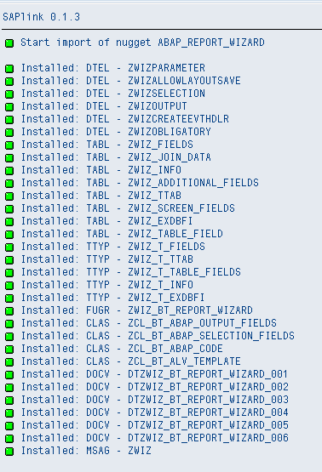

1.2 Activation of Imported Objects

Next, you need to activate all objects which have been imported. Of course, there are a few ways to do this, but in order to insure a clean activation, follow these steps.

- Go to SE80, and select “Inactive Objects” from the object navigator drop down.

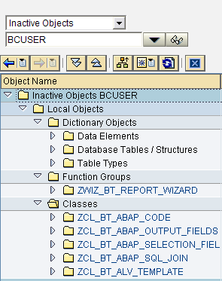

- Open the Data Elements node of the object tree below. Select all data elements by
clicking on the first one, holding down SHIFT and clicking the last, then right-click and choose, “Activate”.
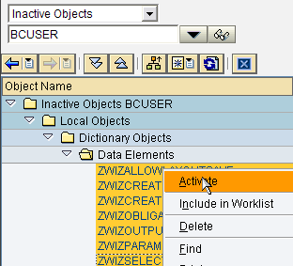

- Next, do the same for the Structures and Table Types at the same time, by selecting
In the same way, click the first, hold SHIFT and click the last, then right-click and “Activate”.
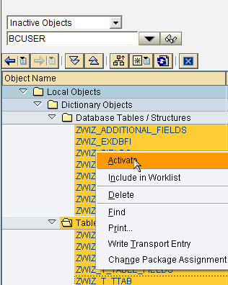

- Lastly, you can now activate the Function Group and the Classes, simply select all, and activate as you did with the other objects.

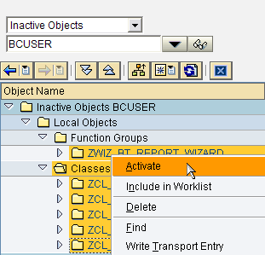

Hopefully, all objects are now activated with out errors.

1.3 Creating the Pattern

In SE80, choose Utilities -> More Utilities -> Edit Pattern -> Create Pattern. In the dialog enter, Z_REPORT_WIZARD and click the green check. In the pattern editor, enter *$&$MUSTER and click “Save” and then the “Back” button.

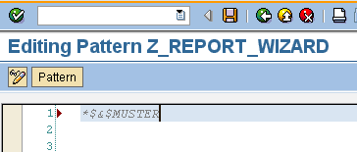

2.1 Starting the Wizard

Now that the pattern has been created, you can now use the wizard. In SE80, put your cursor on an empty line within the source code editor, and click the pattern button.

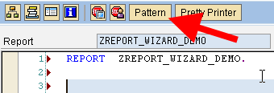

In the dialog, select the radiobutton for “Pattern” and enter the name of the pattern as Z_REPORT_WIZARD and click the green check. The wizard will then be triggered.

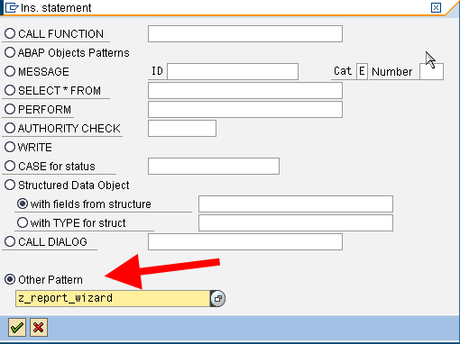

2.2 Using the ABAP Report Wizard

This first screen of the wizard is simply for information purposes, click continue to go to the first step of the wizard. In this step, you will define the title of the report and the data source. You can either do a single table read, or a table join. If you select “Table”, you will be asked to enter the name of the table. If you select “Table Join”, you will be asked to define the table join by clicking the “Define” button.

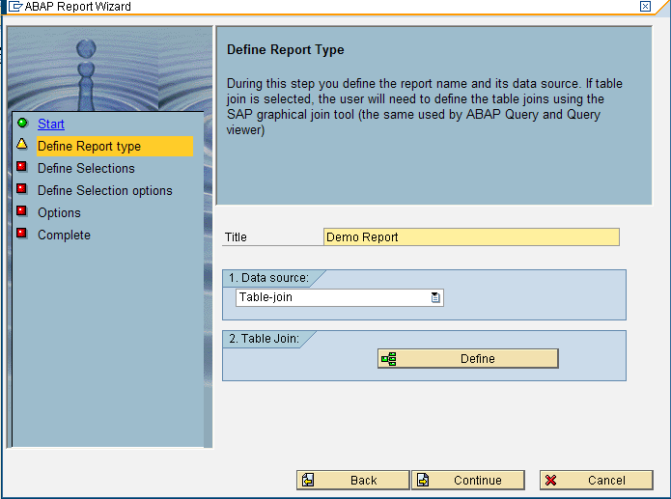

When you click the “Define” button, you will be presented with a graphical join editor. Click the “Insert Table” icon on the application toolbar. Enter the name of the first table in the join.

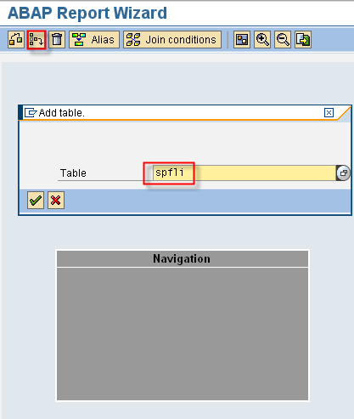

The table will then be added to the display.

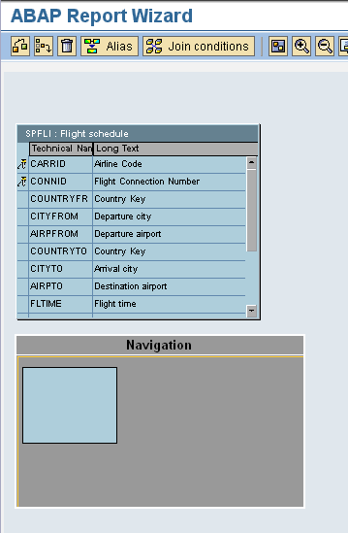

Next, click the “Insert Table” icon on the application toolbar again to add the second table in the join. Again, give the name of the table and hit enter. The graphical editor will then display both tables as well as the join condition between the two. Click the “Back” button to leave the editor.

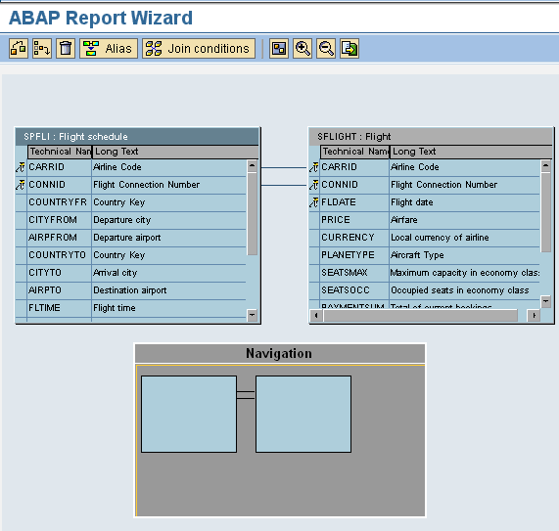

Continuing to the next step of the wizard, you will need to define the selection criteria. This is where you will define what SELECT-OPTIONS or PARAMETERS will be created in your final program. By default, the selections, will be SELECT-OPTIONS, you must check the checkbox for “Parameters” in order to switch to a PARAMETERS statement. You can also define them as obligatory. Click “Continue” when finished defining your selection screen.

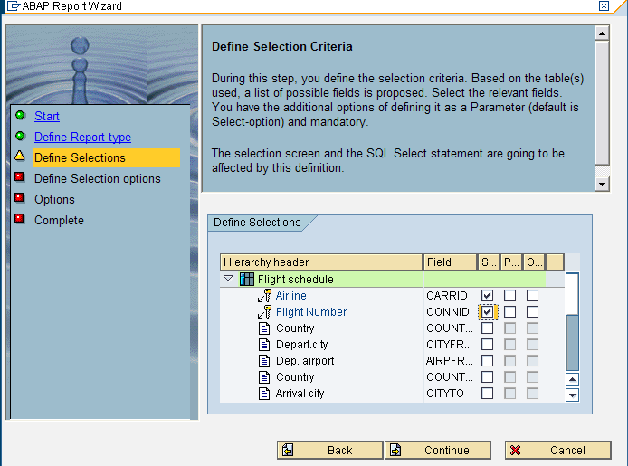

The next step of the wizard is to define the output fields in your report. Open the node of the specific table an select the fields that you want to be displayed in the ALV Output. Click “Continue” when finished selecting your output fields.

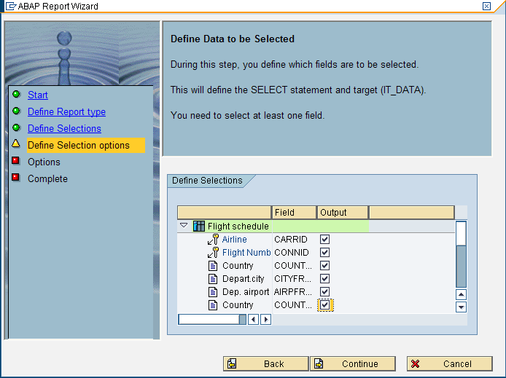

The next step in the wizard is to define some options for your generated report program. Currently there is only two options, event handler generation, and save layout functionality. If you select the “Create Event Handler” option, the wizard with then create a local class for handling events raised by the ALV Grid. If you select “Allow user to save the layout”, the ALV layout functionality will be turned on. Click “Continue”.

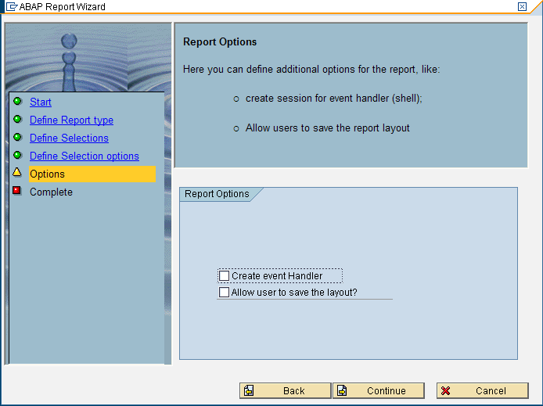

The last screen is a “Completion” screen. Simply click the complete button.

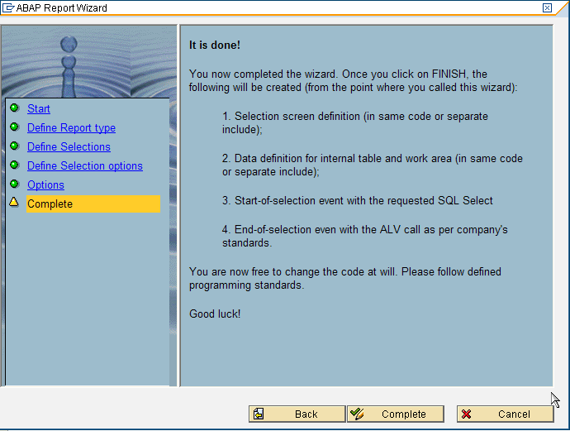

The required source code will then be written to your program, save, activate and run your program. The output will resemble the image below.

